How to arrange historical events?
How to arrange historical events? | Difficulty
How to arrange historical events? | 1

Name︰_______________ （ ） Class︰__________

Historical skill | Measuring time
Related Textbook Content | 1A p.5

In 334 BC, Alexander began his military expedition. | In AD 1914, the First World War broke out.
 | 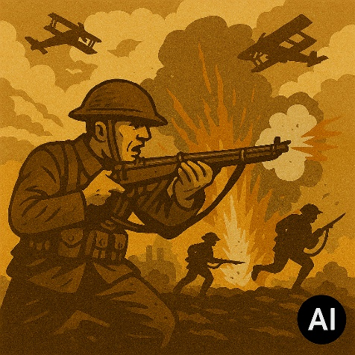
In 3100 BC, Menes unified Egypt. | In AD 1789, the French Revolution broke out.
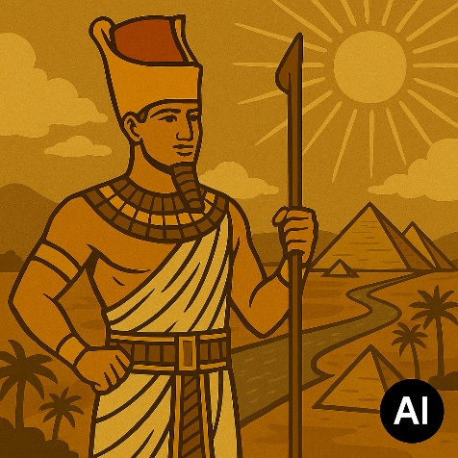 | 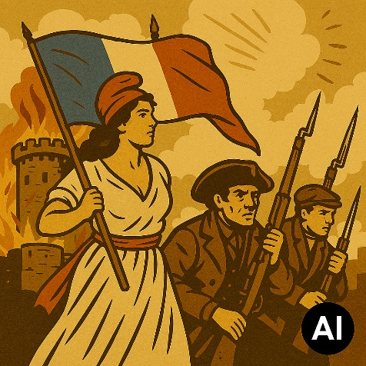

In AD 1, Jesus Christ was born. | In AD 1945, the United Nations was founded.
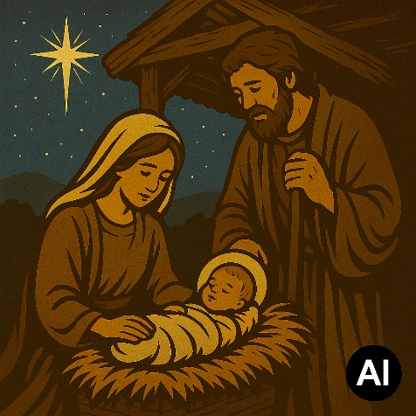 | 

____________________________________________________________

Answers

_____C__________A__________E__________D_________B________F____

